|  |  |  |
| --- | --- | --- |
| **Welcome to your Newsletter!** This Newsletter is designed to give you lots of information in one place. If there is anything you would like to share with the group, please email [admin@u3abridlington.co.uk](mailto:admin@u3abridlington.co.uk) | **Next Month’s Meeting** Next Month’s meeting will be on **Tuesday 29th April** at 10am at Bridlington Spa. This will be a community event with lots of different organisations for you to meet and talk to at your leisure. Full details can be found later in this newsletter. | **Further meeting dates this year** Tuesday 20th May  Monday 23rd June  Monday 14th July |



**Bridlington u3a Newsletter**

**april 2025**

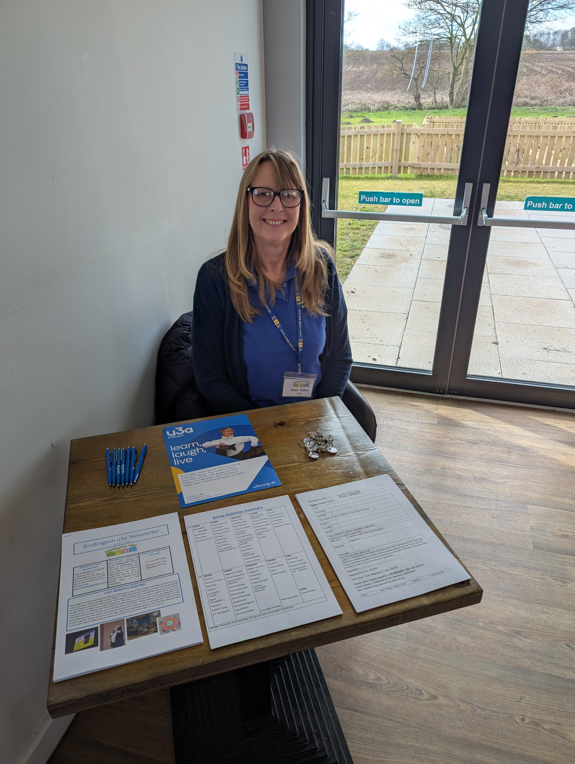

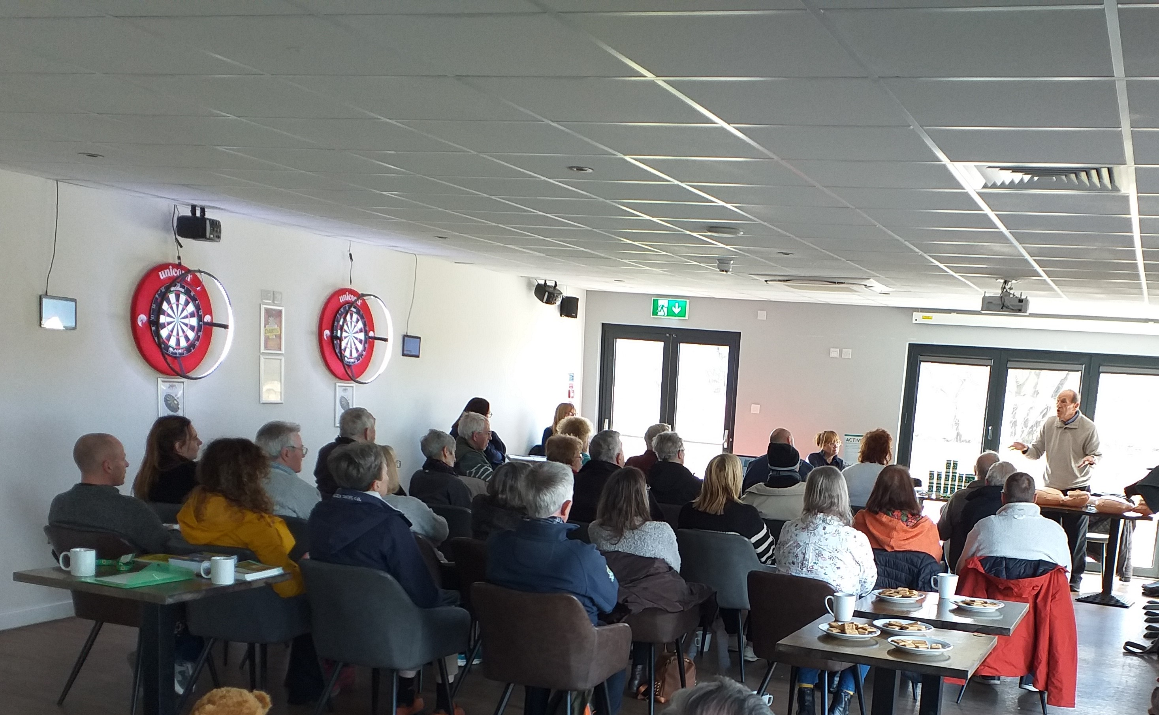

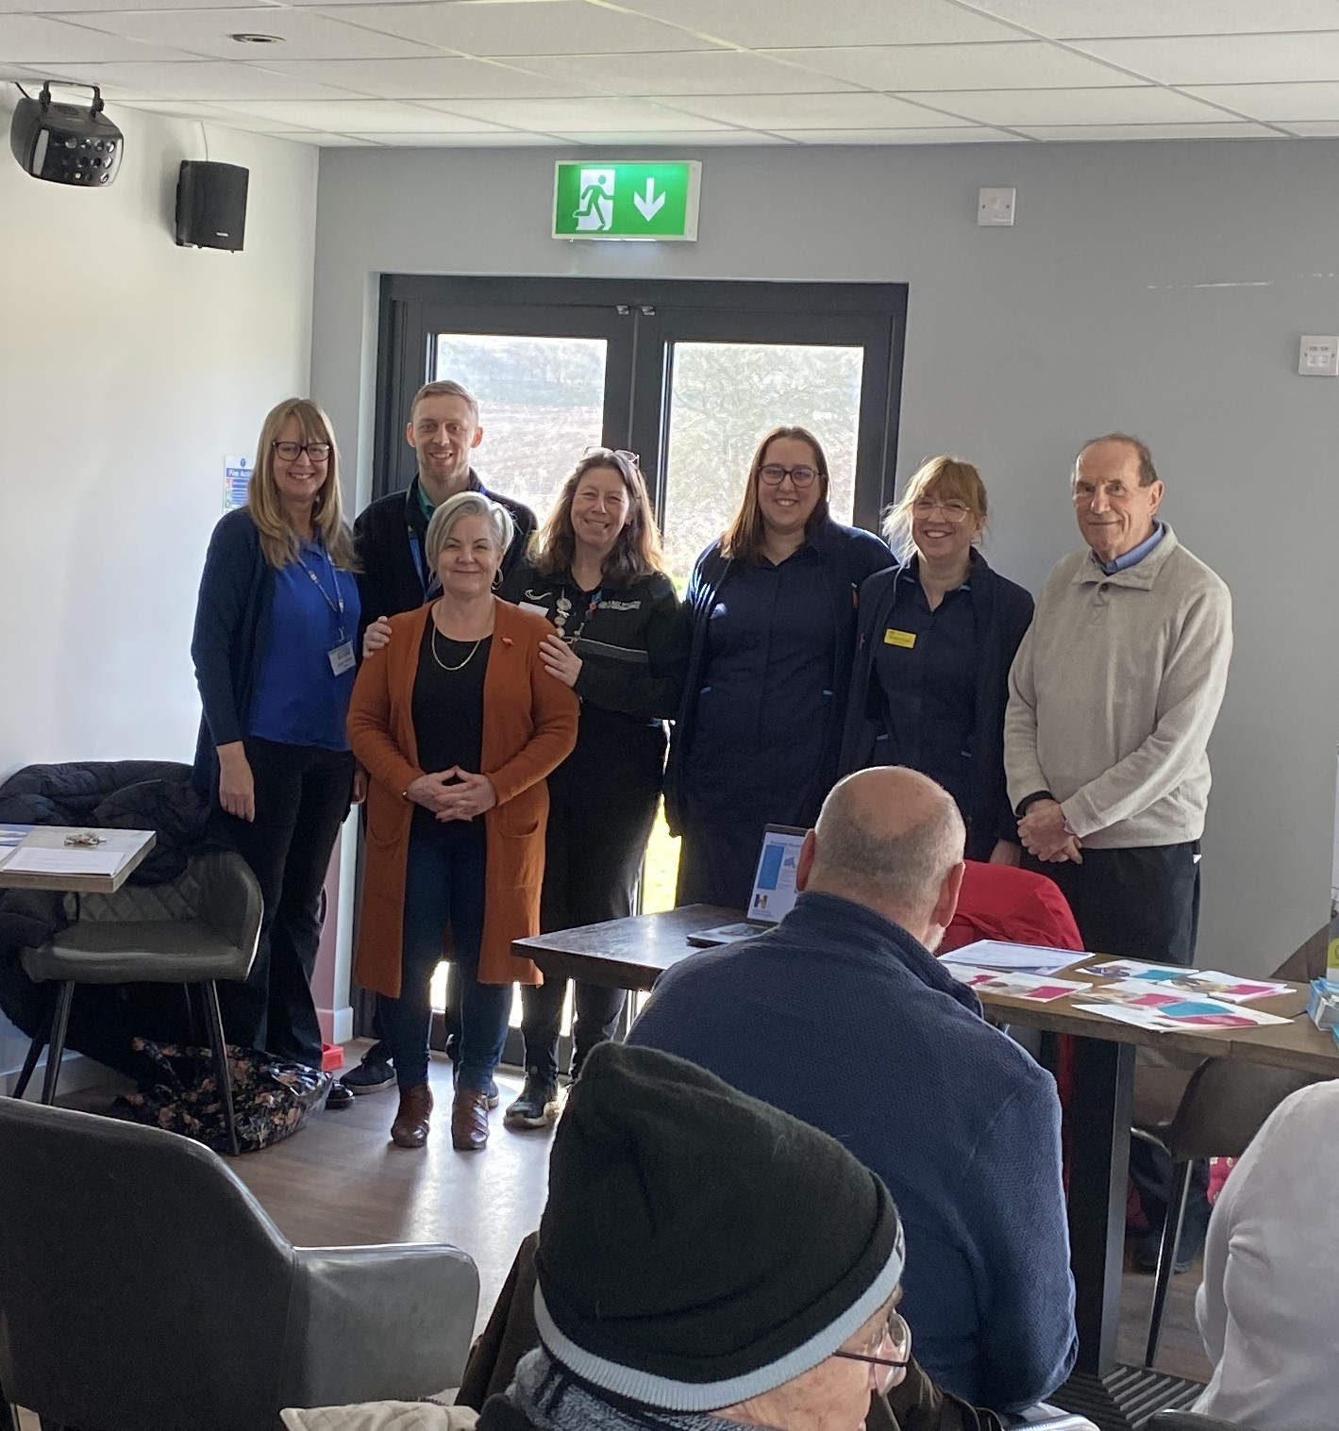

**YOUR CHAIR OUT AND ABOUT**

I attend various local groups representing our u3a including the Bridlington Health Forum, Community Conversations, and the VCSE (Voluntary, Community and Social Enterprise) Network. It means that not only do we have a voice in these groups, but also, I am able to network with other organisations throughout Bridlington and the wider area. Through this I had the pleasure of meeting Trish Dobbs, who is also one of our members. She runs a dementia support charity called Right Minds and invited me to attend one of their meetings alongside Admiral Nurses who support patients with dementia in hospital, Michelle from the Active Communities Team, Aaron a Social Prescriber and Leo who demonstrated how to use a defibrillator, at the CYP Sports Centre to talk to their members about the u3a and what we had to offer. It was a delight to meet the members of the group, which included both those with dementia and their carers. ***Diane Arthur, Chair***

|  |  |  |  |
| --- | --- | --- | --- |
|  |  |  |  |
|  |  |  |  |
|  |  |  |  |

**??*!*? QUIZ ?@!**?**

Our next quiz is at the Town Bar on Queensgate YO16 7LN on Wednesday 26th March 7.30 – 10 pm. Entry fee £1.50 per person. Maximum 6 per team – don’t worry if you’re on your own, we’ll have a friendly team for you to join!

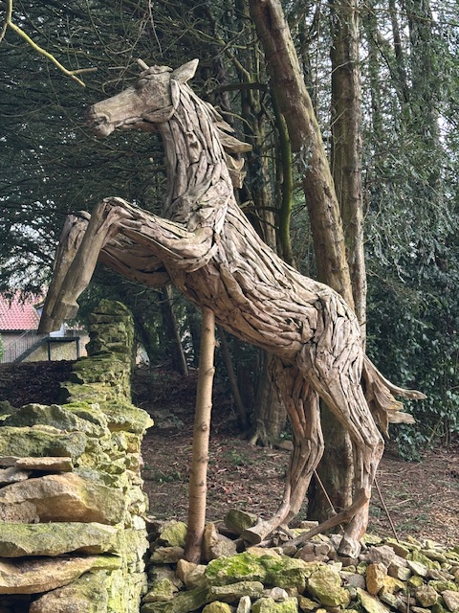

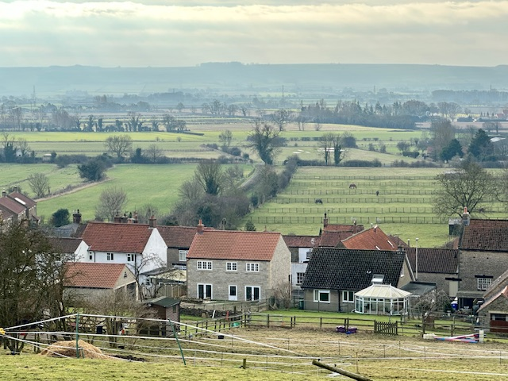

## **GROUP NEWS**

Here are members of **the U3A Over The Hill Mob on** their snowdrop walk from Ebberston to Wyedale Hall on 12th February.



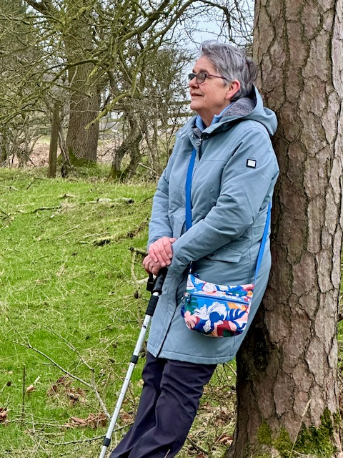

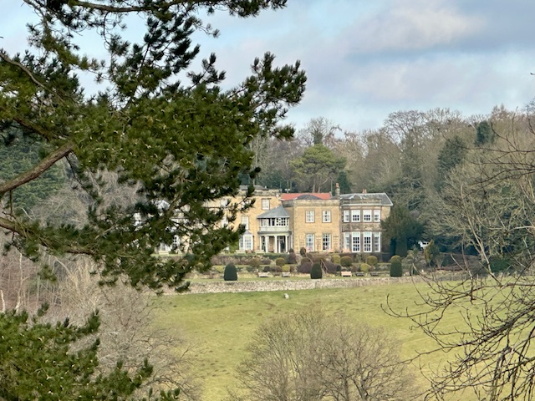

**NEXT MONTH’S SPECIAL MEETING**

As mentioned in last month’s newsletter next month’s meeting will be different to our usual format. I have invited over 40 different local groups – and we are also hoping to encourage more people to join our wonderful u3a too. Each organisation will have a table and you can browse at your own pace. We have been lucky enough to receive a grant from ERYC which means that we have opened the event to the public, so please encourage friends and family to come along. It will be free of charge and refreshments will also be free. The full list of confirmed organisations to date are as follows:

|  |  |
| --- | --- |
| ERYC Electric Bikes | School readers |
| Burlington Probus Club | Xyla Health Services |
| Neighbourhood Watch | Sight Support |
| HEY Credit Union | Your Money Team |
| Humber and North Yorkshire Cancer Alliance | ERYC Active Communities Team |
| East Yorkshire Community Transport/HART | Co-Op Community Team |
| Carers Plus Yorkshire | The Hinge Centre |
| YOUR Health | Mental Health and Wellbeing |
| Humberside Police | Bridlington Lions |
| Bridlington RNLI | Bridlington Town Council |
| St Catherine’s Hospice | Bridlington Talking Newspaper |
| Alzheimers Society | Humber and Wolds Rural action |
| Bridlington Primary Care Network | HEY Smile Foundation |

CREATIVE WRITING

Every month Bridlington Creative Writers are going to contribute a short piece of writing – maybe a story or a poem – for your enjoyment. They meet alternate Wednesdays, 10am at The Friendly Foresters. Please contact on Susie Fox 07736547277 susiejfox14@gmail.com

This month’s contribution is a poem from John Arthur

**Back in the Day ©**John Arthur 2024

|  |  |
| --- | --- |
| Back in the day, when life was quite good  70s simple life no complaints, no moans,  Bell bottomed jeans, Slade and the Stones,  Back in before dark, no mobile phones  We wrote actual letters using a pen,  We walked to school, a posse, a clan,  Now we Empty our spam whenever we can,  friends are remote, that wasn’t the plan.  TVs had knobs, cases, no remote control,  Only a few channels to entertain,  Now streaming floods our screens like the rain,  We scroll, we search, to our distain.  Cameras had film, taking pictures was tough,  Did anyone blink whilst taking that shot,  Now selfies abound, did I look hot,  I will filter the flaws like it or not.  Maps used to unfold, get wet, smudged and torn,  Folding them back was something to see,  Now GPS says we can go hands free,  Watch where you are going, did you see that tree  Arcades were the centre of seaside holiday life,  With coins in hand we tested our luck,  Now we stare at screens, did that suck,  Wifi and earbuds, mind that sign, don’t forget to duck | We mixed tapes with passion, missing the chat,  waiting for the DJ to stop talking fast,  now algorithms guess our next blast,  and shuffles just skip over our past  Books were on paper, with spines which would crack,  We squinted at pages, wild tales uncovered  Now e-readers blink with stories of lovers,  Thousands of books to read, no rediscovers.  Remember phone calls, attached by a wire,  No caller ID each call a surprise,  Now I stare at my mobile, think, agonise,  Shall I ignore this person, be cool, strong, streetwise  Eat Marathon, Black Jacks, fruit salads, and Dime,  A pint of Mild, let’s go down the pub,  Now cream eggs are tiny, Twix is a stub,  Shrinkage is normal, less chocolate on your Club  No internet, no computer to help us at work,  Forms filled manually, with care and attention,  Now only Windows and Word get a mention,  Rat race no, not me, I’ll draw my state pension  So here’s to the Tech that has taken our lives,  Milk bottles on the steps, now plastic thrives,  Deep down we know life was truly fantastic,  We miss those sweet days when we said, naught at all. |

**CONTACT US**

**CHAIR:** Diane Arthur [admin@u3abridlington.co.uk](mailto:admin@u3abridlington.co.uk) 07986 650773

**SECRETARY:** Sue Blake                       [secretary@u3abridlington.co.uk](mailto:secretary@u3abridlington.co.uk)      07484 890410

**MEMBERSHIP:** Linda Sawyer               [membership@u3abridlington.co.uk](mailto:membership@u3abridlington.co.uk)   07716 433228

**TREASURER:** Christine Latham        [treasurer@u3abridlington.co.uk](mailto:treasurer@u3abridlington.co.uk)     01262 851313

**GROUP COORDINATORS:** Brian & Geoff Ellwood  [groups@u3abridlington.co.uk](mailto:groups@u3abridlington.co.uk)   07969 869717

**COMMITTEE MEMBERS:** Carmen Mills [carmen.mills@rocketmail.com](mailto:carmen.mills@rocketmail.com)

Mike Heslop-Mullens:   [mikejhm@yahoo.co.uk](mailto:mikejhm@yahoo.co.uk)

**ITEMS FOR SALE/FREE TO A GOOD HOME**

**PROPERTY TO LET**

Property to let from 1st May. One Bedroom ground floor apartment.

Headlands Close, North Bridlington

Good size lounge, fully equipped kitchen, double bedroom, wet room, patio and garden.

Excellent location just off Martongate. One minute Co-op supermarket, Bridlington North library, Friendly Forester pub and good bus routes.

£575 per calendar month. Email [Steveandjaneward@aol.com](mailto:Steveandjaneward@aol.com)

If you have any property you would like to advertise here, please email [admin@u3abridlington.co.uk](mailto:admin@u3abridlington.co.uk)

**YORKSHIRE**

When in Wales, my friend remarked, superiority we boast,

Of how our Principality and people are the uttermost

In all that’s great. We tell a guest, in everything we are the best.

You are from Yorkshire, why don’t you proclaim to all who hear

How superior you are too, for Yorkshire to raise a cheer?

No need to boast to all and sundry, we know Yorkshire is God’s own country

Its tumbling streams, its hills, its sheep, make Yorkshire wool the finest,

Here the Viking blood runs deep, in farmers, weavers, miners.

And while we speak of all things good, let’s not forget the Yorkshire pud.

Our varied landscape’s grand, by gum, affords breathtaking vista;

East coast excels with cliffs and sands – Jurassic coast here, mister.

Its coastline, 45 miles long, its 3 and a half million acres,

All its variety ensures it’s never short of takers.

Its dialect, with these and thous, show it’s language true,

Not modern Vulgate, like the world has imposed on you.

Cricket’s taken seriously, of that there is no doubt;

Tow teams compete, one is IN, the other side is OUT. Each man that’s in the side that’s IN goes OUT and, when he’s OUT

The next man on the team goes IN, until he too is OUT.

And when all are OUT, the side that’s OUT comes IN, ‘cos it’s their turn,

And, at the end, some are still IN, but most are OUT, we learn.

And Rugby League must have a mention, a sporting game of good intention.

Why don’t we boast, we have no need, Yorkshire is HOME, a heaven indeed.

***Margaret Drysdale***

AN INVITATION FROM OUR SCIENCE AND TECHNOLOGY GROUP…..

**Electric Vehicles: Cutting Through the Noise**  
  
Are you curious about electric vehicles (EVs) but unsure what to believe? With so much conflicting information in the media, it can be hard to separate fact from fiction.  
  
Join us for an engaging talk where we’ll take an honest look at the realities of EV ownership—the benefits, the challenges, and the costs. We’ll also explore alternative vehicle options and cut through the negative press and common misconceptions. Whether you're considering an EV, already own one, or just want to learn more, this is a great opportunity to get the facts.  
  
The talk will conclude with an open Q&A session, so bring your questions!  
  
📍 Venue: **Bridlington Sports Centre, Gypsey Road**  
📅 Date: **Wednesday, 26th March**  
🕑 Time: **2pm**  
  
**All are welcome—come along and join the conversation!**

**Group Activities Summary**

|  |  |  |  |  |  |
| --- | --- | --- | --- | --- | --- |
| **am** | **Monday**  **Spa meeting**  **(Monthly)**  Knit & Natter  Short Walks 1  Tap Dancing for All | **Tuesday**  Continuing French  Book Group  Knitting & Crochet  New Age Kurling 3  Orchestra  Play Reading  Reiki Course  Show Dancing  Trim Intentions/ Weight Management | **Wednesday**  Ballet Fitness  Friendship Circle  Golf Improvers  Greek for Holidays  Mindfulness Meditation  New Age Kurling 1  Over the Hill Mob (Walking Group, Monthly).  Short Strolls  Short Walks 2  Spanish Intermediate  Ukulele Sensation  A Writers Group | **Thursday**  Bible Discussion (Monthly).  Crown Green Bowls  Discussion Group  Gentlemen’s Relish  Map Reading  Round & About Walks  Scrabble | **Friday**  Croquet  Flower Arranging  New Age Kurling 2  Line Dancing  Table Tennis  Watercolours Mixed |
| **pm** | **Monday**  Archery  Acrylics Art Group  Book Club  Canasta 1  Introducing Canasta  Digital Photography  Petanque  Readers’ Group  2nd. Year Spanish | **Tuesday**  Beginners’ Canasta  French Conversation  Literary Studies 2 (Monthly).  Line Dancing Beg.  Poetry Appreciation  Reiki Exchange  Science/Technology  Sewing Group  Uno and Boardgames  Yoga & Pilates  Wine Appreciation | **Wednesday**  Bridge – Improvers  Calligraphy  Photography  Pickleball  Progressive Whist  Spanish – Intermediate /Advanced          Quiz Night (monthly) | **Thursday**  Canasta 2  Climate Change  Italian  Literary Studies              Wine Appreciation | **Friday**  Book Group  Flat Green Bowls  Recorder Ensemble  Rummikub, UNO and     Dominoes          **Sunday**  Canasta Sunday |
| **Variable**: Allotments, Geoarchaeology, Hearing Loss, Silver Dream Bikers, Trips/Events | | | | | |

**TRIPS AND HOLIDAYS**

**LIVERPOOL, LLANDUDNO & LLANGOLLEN**

5 Day/4 Night Coach Trip – 8th September 2025

£355 per person (based on 2 sharing), (supplement for single occupancy of £19pn – limited availability)

Includes return luxury coach travel, 4 nights stay at Beaufort Park Hotel, Mold, with dinner, bed & breakfast, hotel porterage, and 3 excursions. Entrance fees are not included unless stated below

From Beatlemania to Scenic Heights: Exploring Liverpool, Llandudno and the Pontcysyllte Aqueduct

* Visit Liverpool, offering a vibrant mix of history and culture. Explore the bustling Albert Dock, home to the Beatles Story and Tate Liverpool. Marvel at the Royal Liver Building and immerse yourself in the city’s legendary music scene at the Cavern Club. Diverse cuisine and lively streets make Liverpool an unforgettable destination.
* Journey to Llandudno, which offers a blend of Victorian charm and natural beauty.  Nestled between two headlands, the town features a scenic promenade, a historic pier, and stunning coastal views.  Lined with boutique shops and cosy cafes, creating a welcoming atmosphere for a relaxing getaway.
* A boat cruise on the Llangollen aqueduct offers an unforgettable experience that combines serene waters with breathtaking views.  As you glide along the canal, you will traverse the Pontcysylite Aqueduct.  The journey provides stunning vistas of the countryside, allowing you to appreciate the greenery and rolling hills from a unique vantage point.  This trip is not suitable for people with walking difficulties. Entrance is included.

**HOLIDAY TO SCOTLAND**

5 Day/4 Night Coach trip – 14th January 2026

£279 per person (based on 2 sharing). There are a limited number of single rooms available at no additional cost. For a double room at single occupancy the supplemental cost is £20 pppn i.e. £279 + £80 = £359

This includes coach travel, bed, breakfast and evening meal at Duke of Gordon Hotel (Kingussie) and coach excursions (entry fees not included unless stated). Entertainment most evenings. Proposed itinerary for this trip – awaiting finalisation by Cairngorm:

* Highland Wildlife Park (entry fee included) – a drive-through safari park as well as enclosures with rarely see native wildlife, as well as species that once roamed the Scottish Hills and many iconic species from around the world. The new visitor centre is due to open ready for 2026.
* Fort George and Nairn Fort George, one of the most outstanding fortifications in Europe was built in the wake of the Battle of Culloden (1746) and is home to the Highlanders museum (English Heritage membership enables free admission to Fort George). Fort George is currently home to the Black Watch.
* Nairn is an ancient fishing port and market town.
* Dundee. Many and varied paces to visit, including the McManus Museum (free entry), V & A, Mills Observatory and an opportunity for retail therapy.

If you would like to join either of these trips, or would like any further information, please contact Sylvia Wright via email [silverladybrid@gmail.com](mailto:silverladybrid@gmail.com) or call 01262 672721 to reserve your seat and request a booking form.  A deposit of £50 per person is payable on completion of the booking form – deposits to be paid by the end of March. Sylvia will be at Bridlington Belvedere Golf Club (restaurant) on Mondays from 10.30am to 11.30am so you can collect/return your booking form.

**AND FINALLY…..**

**THE MAGIC OF UKULELES**

Generally, the ukulele is regarded as a happy instrument. It is commonly believed to have its origin in Hawaii and it is easy to conjure up a vision of players strumming away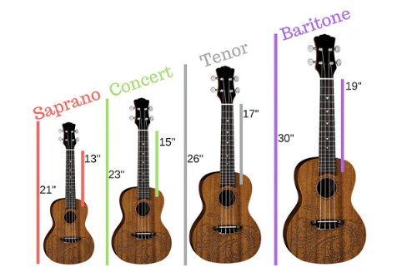 under palm trees with waves breaking on golden sands in the background.



That may well be the case in Hawaii today but research indicates the ukulele was originally being played in Portugal during the eighteenth century. The present popularity of ukuleles (ukes) can be attributed to their small size and relatively low cost. Presently you will need to pay around £50 for an instrument that it is easy to play and sounds good. Below £50 you may have a few rough edges for your fingers to deal with and the sound you get, compared to other ukes may wish you had spent a bit more. There is a lot of hype about which uke gives the best sound – in reality it is the player that makes the big difference.

There are four basic uke sizes. The smallest “Soprano “size provides a more treble sound. Many parents buy the Soprano size for their children assuming it will be easier for small fingers to handle. In reality it is the most difficult instrument to play. Do we give kids miniature pianos to play? No way! Look on the internet and you will find 6-year-old kids handling a full size, grand’ piano with great dexterity.

Learning to play the ukulele is relatively easy compared to other musical but to be an accomplished player it takes discipline and lots and lots of practice. “Little and often” is the secret. Three 10-minute sessions are so much better than a single half-hour stint. These days there is a lot of help available on the internet using the “Youtube” app.

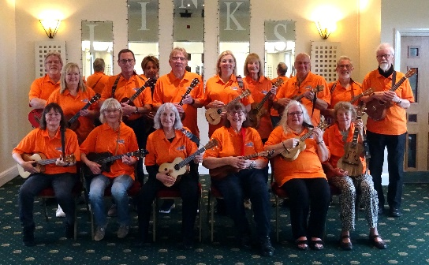There are many health benefits associated with playing a ukulele. In my own case it has considerably reduced the pain in my ancient arthritic fingers and very much improved their mobility. I have heard many reports of learning a musical instrument staving off the symptoms of dementia. I complete this article with a photo of Bridlington’s U3A ukulele group “Ukulele Sensation”. Everyone looks very happy – don’t they.

**Bill Western – Group Leader**